
23/12/2025
Project Image Processing
College of Information Technology
Medical Image Analysis for Cancer Cell Classification Using MATLAB
Image Enhancement and Noise Reduction for Cancer Cell Images Using MATLAB

Team number: G17
Members by University ID Number and Names:
- 202402593 يزيد محمد عيسى الحاج
- 202300700محمد عمر كمال ابوخميش
- 202402687 عمر موسى سلمان أبو عنزة
- 202402595 سعد مصطفى احمد خليفات

Digital Image Processing Project Documentation

Introduction
Digital Image Processing (DIP) is a fundamental field in computer science and engineering that focuses on the manipulation and analysis of digital images using computational techniques. It plays a vital role in many real-world applications, including medical imaging, image enhancement, pattern recognition, and computer vision.
This project presents a detailed implementation of various digital image processing techniques using MATLAB, with a focus on image enhancement and noise reduction. The experiments were conducted on medical images of cancer cells in order to analyze how different types of noise affect image quality and how spatial domain filters can be used to improve visual clarity.
The project includes the application of grayscale conversion, noise addition, histogram analysis, and filtering techniques. Two common types of noise, namely Salt & Pepper noise and Gaussian noise, were added to the images to simulate real-world image degradation. Several filters provided in the course material were then applied to evaluate their effectiveness in noise removal.
The impact of each processing step was analyzed both visually and statistically using histograms. This comparison allows for a better understanding of how image transformations influence pixel intensity distribution and overall image quality.

Project Objectives
- The main objectives of this project are:
- To explain the mechanisms of applying digital image processing techniques to digital images.
- To study the effect of different types of noise on image quality.
- To analyze the performance of various spatial domain filters in noise reduction.
- To compare image results before and after processing using visual inspection and histogram analysis.

Project Steps
- Import the original color image into MATLAB.
- Convert the image to grayscale format.
- Display the original and processed images.
- Add different types of noise to the image.
- Apply suitable filtering techniques for each type of noise.
- Analyze the results visually and using histogram distributions.
- Save the output images for inclusion in the final report.

Methodology:
Salt & Pepper Noise
Grayscale Image and Histogram
Description
A grayscale version of the original image was generated to simplify the image representation and reduce computational complexity. The histogram of the grayscale image was calculated to analyze the distribution of pixel intensity values.

Applied Filters
The following four filters were applied to the noisy image:
- Median Filter
- Max Filter
- Min Filter
- Average (Box) Filter

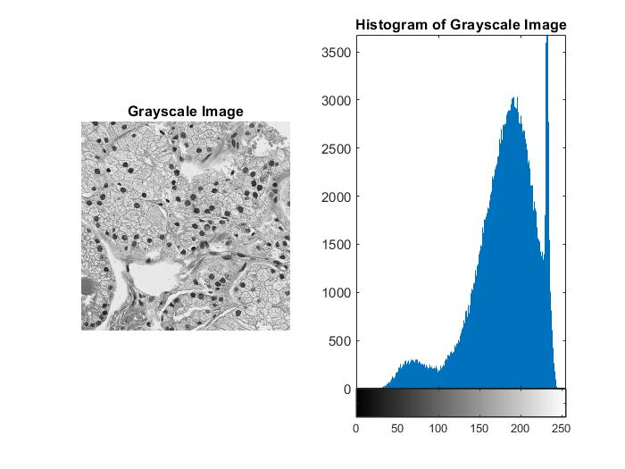
Grayscale image + Histogram

The Code of Grayscale image + Histogram:

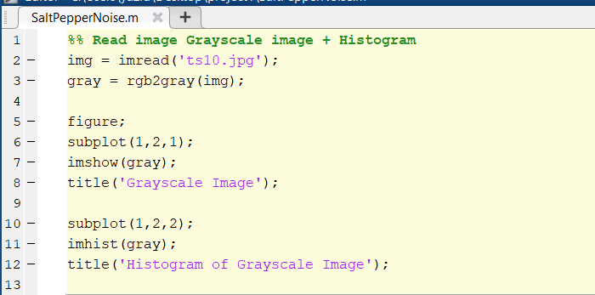

Salt & Pepper Noise and Histogram
Description
Salt & Pepper noise was added to the grayscale image to simulate impulse noise. The histogram was used to observe the effect of noise on pixel intensity distribution.
The Noisy Image and Its Histogram
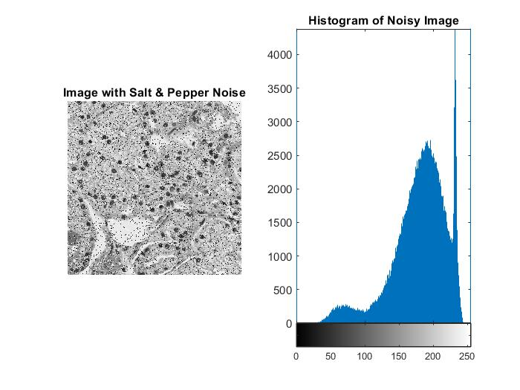
The Code of Salt & Pepper Noise
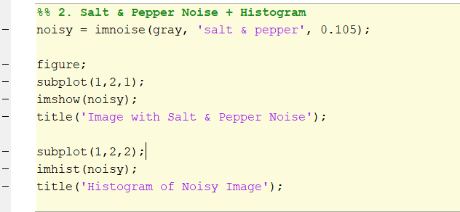

Median Filter and Histogram
Description
The median filter was applied to the noisy image to reduce impulse noise while preserving image details.
The Filtered Image and Its Histogram
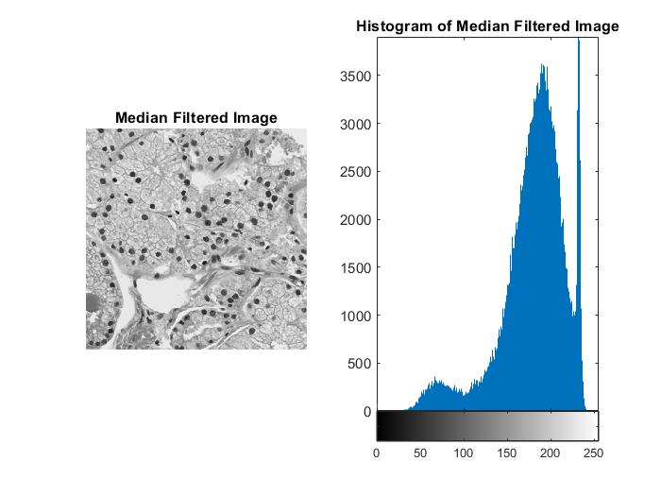
The Code of Median Filter
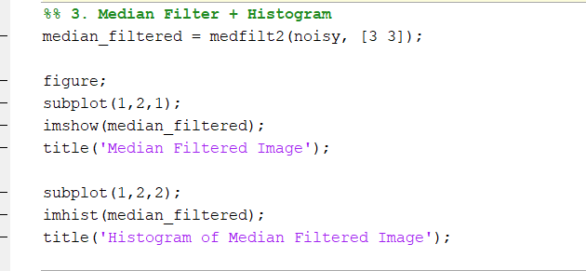

Max Filter and Histogram
Description
The max filter was applied to reduce pepper noise (dark pixels) by replacing each pixel with the maximum value in its neighborhood. Histogram analysis was used to observe the effect of the filter on pixel intensity distribution.

The Filtered Image and Its Histogram
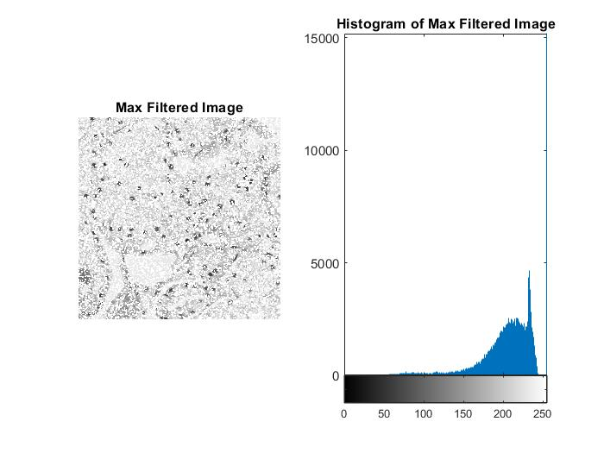
The Code of Max Filter
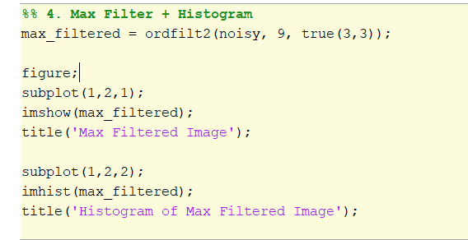

Min Filter and Histogram
Description
The min filter was applied to reduce salt noise (bright pixels) by replacing each pixel with the minimum value in its neighborhood. The histogram was used to analyze changes in image intensity values after filtering.
The Filtered Image and Its Histogram
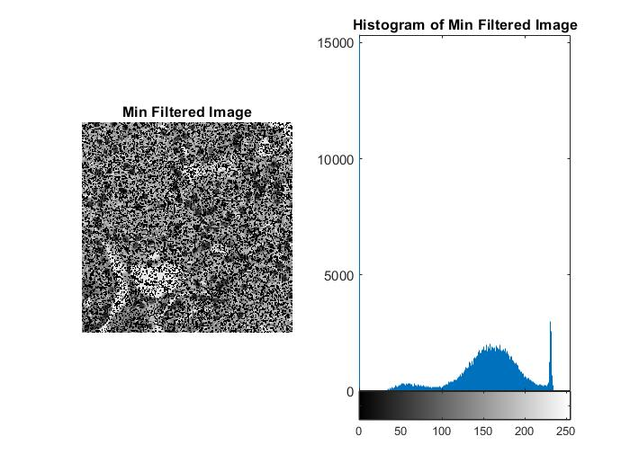
The Code of Min Filter
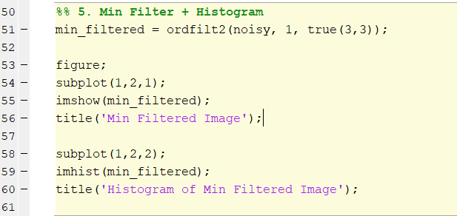

Average Filter and Histogram
Description
The average (box) filter was applied to smooth the noisy image by averaging pixel values within a local neighborhood. Histogram analysis was used to observe the smoothing effect and loss of details.
The Filtered Image and Its Histogram
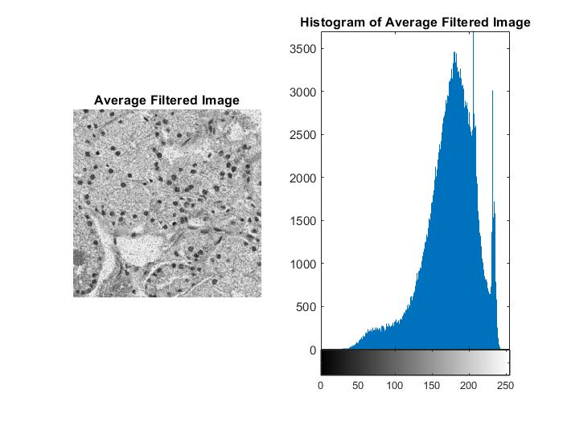
The Code of Average Filter
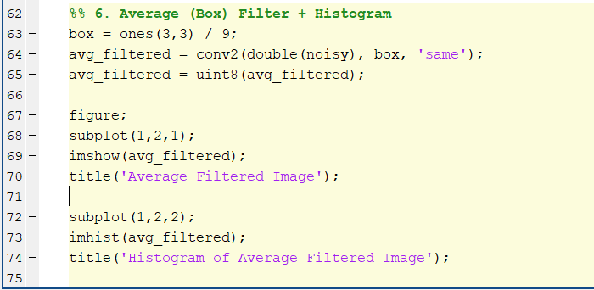

The Results Of All Filters
Based on visual inspection and histogram analysis, the Median Filter provided the best performance in removing Salt & Pepper noise while preserving important image details. Its histogram was very similar to that of the original grayscale image, indicating effective noise reduction with minimal distortion.
The Max Filter reduced pepper noise but increased brightness and caused some loss of details, while the Min Filter reduced salt noise but darkened the image and reduced details. The Average (Box) Filter was ineffective, as it caused image blurring without adequately removing impulse noise.

Gaussian Noise
Description
Gaussian noise was added to the grayscale image to simulate random noise commonly caused by sensor and acquisition imperfections. Histogram analysis was used to study the effect of Gaussian noise on pixel intensity distribution.

Applied Filters
The following four filters were applied to the noisy image:
- Average (Box) Filter
- Arithmetic Mean Filter
- Harmonic Mean Filter
- Median Filter
Grayscale Image and Histogram
Description
A grayscale version of the original image was generated to simplify the image representation and reduce computational complexity. The histogram of the grayscale image was calculated to analyze the distribution of pixel intensity values.

Grayscale image + Histogram

The Code of Grayscale image + Histogram:
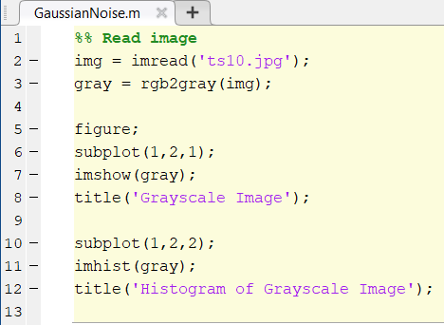

Gaussian Noise
The Gaussian Noise & Histogram
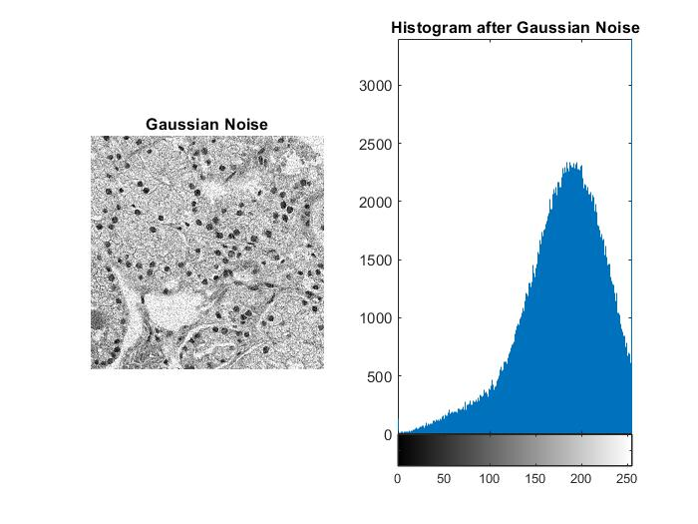
The Code of Gaussian Noise & Histogram
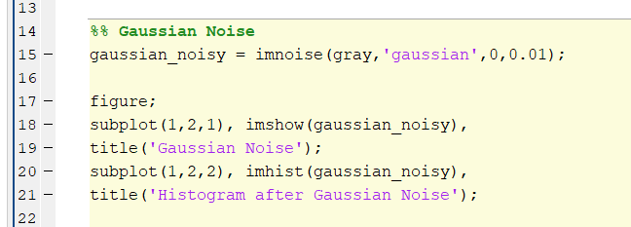

Average (Box) Filter and Histogram
Description
The average (box) filter was applied to reduce Gaussian noise by averaging pixel values within a local neighborhood. The histogram shows a smoother intensity distribution compared to the noisy image, indicating effective noise reduction.
The Image and Its Histogram
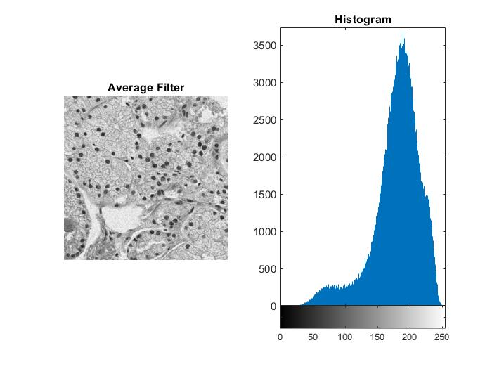
The Code of Average (Box) Filter
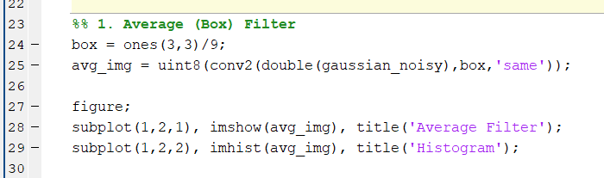

Arithmetic Mean Filter and Histogram
Description
The arithmetic mean filter was applied to smooth the Gaussian noisy image. Histogram analysis shows reduced intensity variations, reflecting improved image smoothness.
The Image and Its Histogram
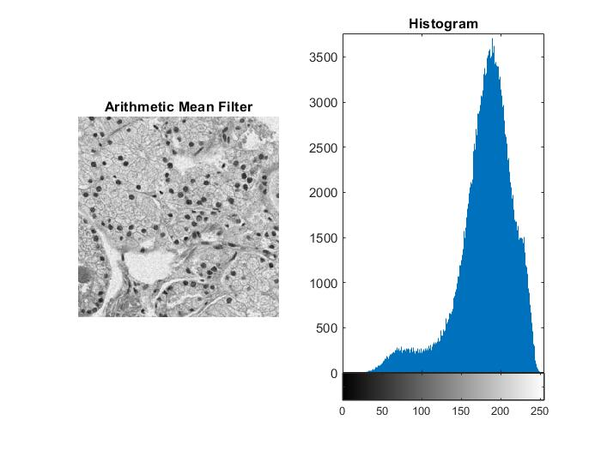
The Code of Arithmetic Mean Filter
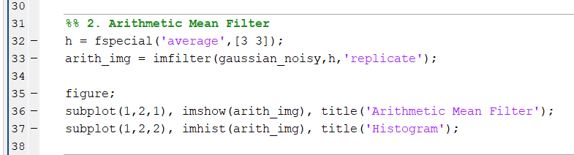

Harmonic Mean Filter and Histogram
Description
The harmonic mean filter was used to reduce Gaussian noise by suppressing extreme intensity values. The histogram shows a more concentrated distribution compared to the noisy image.
The Image and Its Histogram
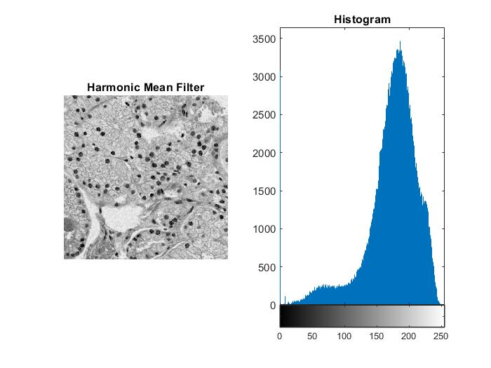
The Code of Harmonic Mean Filter
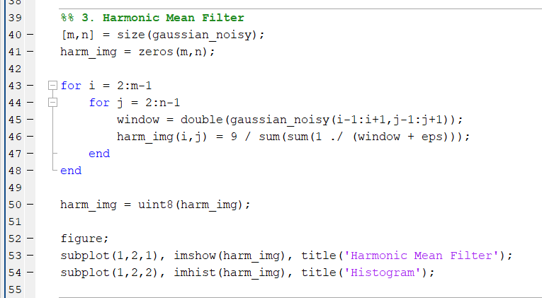

Median Filter and Histogram
Description
The median filter was applied to the Gaussian noisy image for comparison purposes. The histogram shows limited improvement, indicating that the median filter is less effective for Gaussian noise.
The Image and Its Histogram
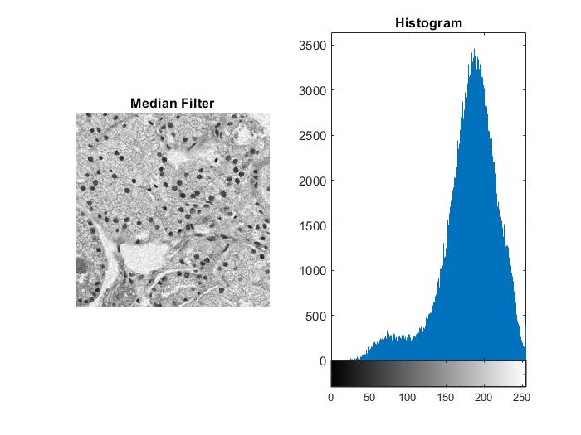
The Code of Median Filter
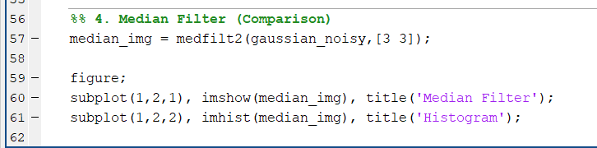
Gaussian Noise – Filter Evaluation
The Arithmetic Mean Filter gave the best results for Gaussian noise. It reduced noise effectively while keeping image details, and its histogram was closest to the original grayscale image.
The Average Filter reduced noise but caused noticeable blurring.
The Harmonic Mean Filter showed limited improvement.
The Median Filter was less effective for Gaussian noise.
Conclusion:
The Arithmetic Mean Filter is the best choice because Gaussian noise is statistical, and mean-based filtering reduces it efficiently.

